1. ***Zabbix****is an open source software for networks and application monitoring.*
2. *Zabbix uses several options for collecting metrics, including agent less monitoring of user services and client-server architecture.*
3. *The Zabbix server stores its data in a relational database powered by MySQL, PostgreSQL.*
4. *Zabbix uses Zabbix Agent installed on monitored hosts to collect the data.*

***Now Configuration of Zabbix -Server***

***Step1:*** wget https://repo.zabbix.com/zabbix/4.2/ubuntu/pool/main/z/zabbix-release/zabbix-release_4.2-1+bionic_all.deb

***Step2:*** *dpkg -i zabbix-release_4.2-1+bionic_all.deb*

***Step3:*** apt update

***Then install the Zabbix server and web frontend with MySQL database***

***Step4:*** apt install zabbix-server-mysql zabbix-frontend-php -y

***Step5:*** apt install zabbix-agent -y

***Now create a database for our Zabbix by logging in Maria DB-Server***

***Step6:*** mysql -u root -p

***Step7:*** mysql> create database zabbix character set utf8 collate utf8_bin;

***Step8:*** *mysql> grant all privileges on zabbix.* to zabbixuser@localhost identified by 'temp123';*

*and*

*mysql> flush privileges;*

***Step9:*** mysql> quit;

***Now import the initial schema and data in MySql Database***

***Step10:*** cd /usr/share/doc/zabbix-server-mysql

***Step11:*** gunzip create.sql.gz

***Step12:*** mysql -u zabbixuser -p zabbix < create.sql

***Step13: Enter Zabbix Password***

***Edit the Zabbix configuration file to Update Timezone***

***Step14:*** vi /etc/zabbix/apache.conf

***Uncomment The Time zone Line***

***Step15:*** php_value date.timezone Asia/Kolkata

***Zabbix server to use database, need to set the database password in the Zabbix server configuration file***

***Step15:*** vi /etc/zabbix/zabbix_server.conf

DBhost= localhost

DBname=zabbix

DBuser=zabbixuser

DBpassword=temp123

***Step16:*** systemctl restart apache2

***Step17:*** systemctl start zabbix-server

***Step18:*** systemctl enable zabbix-server

***Now go on Web Browser And put it***

http://192.168.72.80/zabbix/

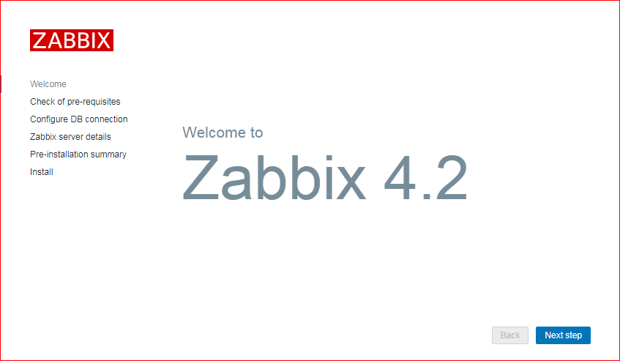

***Now click Next Step on Zabbix welcome page***

***next screen for database connection information as below.***

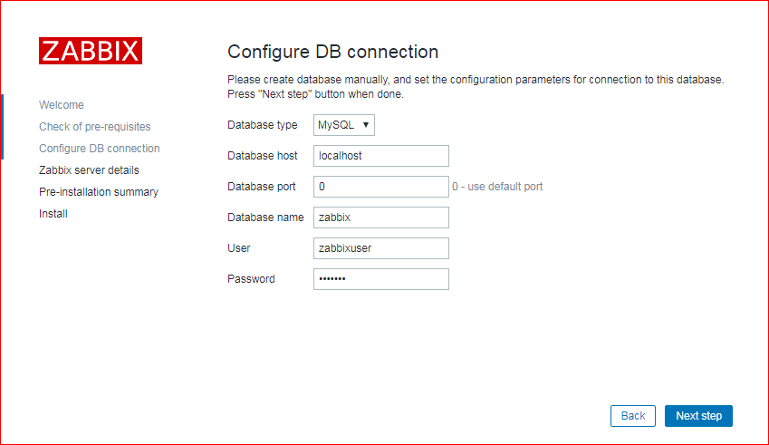

***click on the Next Step.***

***Log in to Zabbix Server with the default username and password given***

Username: “Admin”

Password: “zabbix”

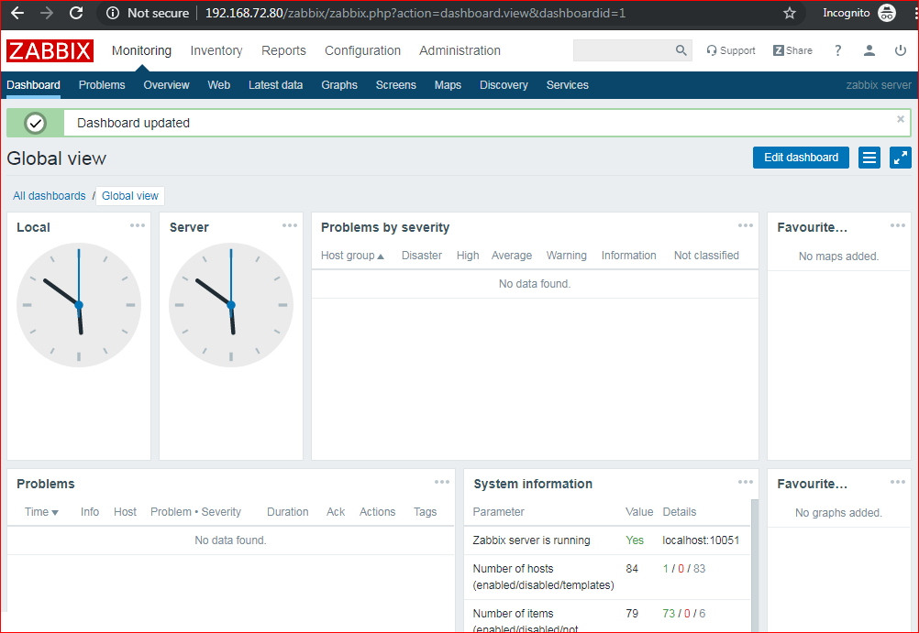

***Install & Configure the Zabbix Agent***

***At Ubuntu***

wget https://repo.zabbix.com/zabbix/4.2/ubuntu/pool/main/z/zabbix-release/zabbix-release_4.2-1+bionic_all.deb

dpkg -i zabbix-release_4.2-1+bionic_all.deb

***Install the Zabbix agent***

apt update

apt install zabbix-agent

***At Centos***

*rpm -Uvh https://repo.zabbix.com/zabbix/4.2/rhel/6/x86_64/zabbix-release-4.2-1.l6.noarch.rpm*

*yum clean all*

*yum install zabbix-agent -y*

***Now edit the Zabbix agent settings to set up its secure connection to the Zabbix server. Open the agent configuration file***

***Firstly edit the IP address of the Zabbix server in agent file***

vi /etc/zabbix/zabbix_agentd.conf

### Zabbix Server IP Address or Hostname ###

Server=192.168.72.80

### Client Hostname ###

Hostname=ubuntu.deep.com

***For ubuntu***

systemctl restart zabbix-agent

systemctl enable zabbix-agent

ufw allow 10050/tcp

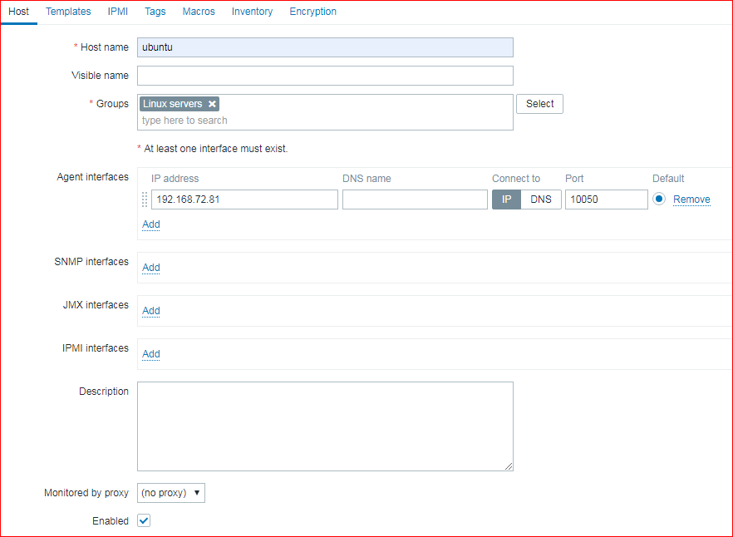

After it go on templates and add templates;

***For Centos***

systemctl restart zabbix-agent

systemctl enable zabbix-agent

systemctl disable firewalld